# **Staj Yol Haritamız**

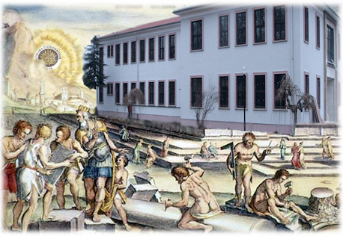

|  |  |  |
| --- | --- | --- |
| C:\Users\ERCÜ\Desktop\BASKENT WEB\WEB BASKENT VOLKİ (www.baskent.ankara.edu.tr )\images\staj01.gif | | |
| [C:\Users\ERCÜ\Desktop\BASKENT WEB\WEB BASKENT VOLKİ (www.baskent.ankara.edu.tr )\images\staj_ok.gif](file:///C:\Users\ERCÜ\Desktop\BASKENT%20WEB\WEB%20BASKENT%20VOLKİ%20(www.baskent.ankara.edu.tr%20)\images\ekler\Ek%202.pdf) | | |
| [C:\Users\ERCÜ\Desktop\BASKENT WEB\WEB BASKENT VOLKİ (www.baskent.ankara.edu.tr )\images\staj02.gif](file:///C:\Users\ERCÜ\Desktop\BASKENT%20WEB\WEB%20BASKENT%20VOLKİ%20(www.baskent.ankara.edu.tr%20)\images\ekler\sgk_dilekce.docx) | [C:\Users\ERCÜ\Desktop\BASKENT WEB\WEB BASKENT VOLKİ (www.baskent.ankara.edu.tr )\images\staj03.gif](file:///C:\Users\ERCÜ\Desktop\BASKENT%20WEB\WEB%20BASKENT%20VOLKİ%20(www.baskent.ankara.edu.tr%20)\images\ekler\staj_basvuru_formu.xlsx) | C:\Users\ERCÜ\Desktop\BASKENT WEB\WEB BASKENT VOLKİ (www.baskent.ankara.edu.tr )\images\staj04.gif |
| [C:\Users\ERCÜ\Desktop\BASKENT WEB\WEB BASKENT VOLKİ (www.baskent.ankara.edu.tr )\images\staj_ok.gif](file:///C:\Users\ERCÜ\Desktop\BASKENT%20WEB\WEB%20BASKENT%20VOLKİ%20(www.baskent.ankara.edu.tr%20)\images\ekler\Ek%202.pdf) | | |
| C:\Users\ERCÜ\Desktop\BASKENT WEB\WEB BASKENT VOLKİ (www.baskent.ankara.edu.tr )\images\staj05.gif | | |
| [C:\Users\ERCÜ\Desktop\BASKENT WEB\WEB BASKENT VOLKİ (www.baskent.ankara.edu.tr )\images\staj_ok.gif](file:///C:\Users\ERCÜ\Desktop\BASKENT%20WEB\WEB%20BASKENT%20VOLKİ%20(www.baskent.ankara.edu.tr%20)\images\ekler\Ek%202.pdf) | | |
| [C:\Users\ERCÜ\Desktop\BASKENT WEB\WEB BASKENT VOLKİ (www.baskent.ankara.edu.tr )\images\staj06.gif](file:///C:\Users\ERCÜ\Desktop\BASKENT%20WEB\WEB%20BASKENT%20VOLKİ%20(www.baskent.ankara.edu.tr%20)\Staj01.html) | | |
| [C:\Users\ERCÜ\Desktop\BASKENT WEB\WEB BASKENT VOLKİ (www.baskent.ankara.edu.tr )\images\staj_ok.gif](file:///C:\Users\ERCÜ\Desktop\BASKENT%20WEB\WEB%20BASKENT%20VOLKİ%20(www.baskent.ankara.edu.tr%20)\images\ekler\Ek%202.pdf) | | |
| [C:\Users\ERCÜ\Desktop\BASKENT WEB\WEB BASKENT VOLKİ (www.baskent.ankara.edu.tr )\images\staj07.gif](file:///C:\Users\ERCÜ\Desktop\BASKENT%20WEB\WEB%20BASKENT%20VOLKİ%20(www.baskent.ankara.edu.tr%20)\images\ekler\Ek%209.pdf) | | |